

Name: **LOW JUN LING**

Login ID: **lowjunling@oasis-portal.com**

Course title: **Essentials of Marketing and Customer Relationships**

Subject Code: **BHM02**

Submitted date:17/07/2017

**Table of Contents**

|  |  |  |
| --- | --- | --- |
| No | Details | Page |
| 1 | Executive Summary | 2 |
| 2 | Introduction | 3 |
| 3 | Assignment Question |  |
|  | Part 1 | 4-5 |
|  | Part 2 | 6-7 |
|  | Part 3 | 8-9 |
|  | Part 4 | 10-11 |
| 4 | Conclusion | 12 |
| 5 | References | 13 |
|  | Appendix | 14 |

**Executive Summary**

In the module, I studied Marketing and Customer Service in Hospitality Management. First of all, I talking about the introduction in Marketing and Customer Service in Hospitality. In the introduction, tells what is marketing? There are some marketing operations and plans. In first question, I demand briefly explain about Marketing in Hospitality and The importance of Hospitality Marketing. In second question, I understand the differences between Marketing and Customer Service. Simultaneously, I studied the Ethics of Marketing and Customer Service in Hospitality and also required to show relevant examples of Marketing and Customer Service. Third part, I will describe about Marketing strategies and how you can apply this in Hospitality Management with Relevant Examples. Finally, I explain topics on the detail on customer service skills and characteristics as well as explain the importance of hospitality customer service department.

.

**Introduction**

Marketing is planning, planning how to find, create and deliver value to meet the needs of a certain target market. Marketing in the business world is a great discipline in the implementation of concepts, pricing promotions and distribution to provide ideas in the goods and services to meet the individual and organizational goals, the essence is designed to meet individual needs and needs of the transaction or exchange. In addition, marketing is used to identify unmet needs, define, measure the size and profit potential of the target market, find the market segment that is best suited for business entry, and market choice, brand, relationship and network and market offerings. Create customer relationships and value through marketing. Marketing is constantly changing the taste of consumers and changing competitive products, and then requires organizations to continuously search for and provide new value for customers, otherwise sales will fall and the organization will die. . To give an illustration, Malaysia Air asia is the first low-cost carrier to expand outside, Malaysia is not a wealthy country, all of them against the customer's ability and needs, will be in some holidays, do promotions to meet the consumer. Marketing aims to find the needs and wants potential customers, such trading ideas can be considered between the buyers and sellers of the value of the transaction, so after the transaction are met.

** ***Dave Schneider (2017)***

***Figure 1: CRM MODELS***

**Assignment Questions**

**Question 1**

Briefly explain about Marketing in Hospitality and The importance of Hospitality Marketing.

The meaning of Marketing in Hospitality is the business for the customer's needs, to create the value of each other, to establish and maintain the relationship between the two sides to get better satisfaction. Firms will be through the consumer to market segmentation, first of all to understand their consumers which types, and then according to the target to choose their own most dominant consumers, coupled with identify themselves in these consumers to occupy "Most needed" position. Similarly, after the firms to exclusive target consumer thinking in the target position as the starting point and the target for the customer to create a good product, good brand and good price, and then spread the value of promotional products in a good place. By doing these values to create work, we can build and maintain relationships with our customers through customer relationships and continue to receive a return on product profits and brand profits. These processes are well handled, and marketing is usually successful. If the link is a problem, then the enterprise will face a crisis of survival.

The following about the importance of Hospitality Marketing.

* **Getting World Out**

As a successful business, must be promoted to let buyers know, whether it is to provide its products or services. And often need to communicate with customers, so that they feel that you care and care for them, so they will have a good evaluation to help promote your products or services. Or you can use your marketing strategy to create your business. In a business, if there is no marketing, your business may not have the opportunity to progress and succeed. Your potential customers may never know your business. Successful companies are using marketing to promote products or services, to promote their own brand, only to get better development.

* **Higher Sales**

When your products let everyone know, they are likely to become your customers, but also increase the opportunity for consumers to buy. You will find that the increase in sales. Your sales will grow steadily with the spread of marketing. If you do not use the marketing strategy, a business is difficult to succeed because no one knows the existence of this company.

* **Company Reputation**

"Trust" is a must for a successful company. The establishment of a reliable and solid image is very important to the beginning of the marketing business, success often depends on the credibility. A company to build trust is not one to two months can be formed, marketing and advertising through the company to establish brand recognition, when the public's high expectations, its reputation even more determined. People will trust you, you will buy your products and services. So that your business will expand and sales will follow the growth.

* **Healthy Competition**

Marketing promotes healthy competition in the market. Marketing products and services pricing, will meet with other companies to compete with consumers business. Every company has its own marketing, and potential consumers have the right to choose the best. If there is no competition, those new companies and small businesses are simply not successful opportunities, and then the well-known companies will continue to sell, develop even more. Marketing to promote healthy competition, enabling small businesses and new businesses have the opportunity to enter the market, to be successful.

* **Considerations**

Marketing is important to an enterprise, marketing is like investment, not necessarily everyone's success does not necessarily fail each, and it can also be very expensive. Such as through web development, printing, broadcasting. In the newly established new company, many will be half of its sales to do marketing plans. So in the newly established new company, basically do not earn money, but marketing can help you in the future business marketing to achieve a very good development and very good sales.

 ***ALWYN COSGROVE*** ***(2016)***

***Figure 2: PLANNING FOR MARKETING***

**Question 2**

Explain the difference between Marketing VS Customer Service.

Explain the Ethics of Marketing and Customer Service.

|  |  |
| --- | --- |
| Marketing | Customer Service |
| * Creativity   Marketing needs to be thought and explored, in a variety of social practice performance, to achieve the ability to create results.   * Analytical   Marketing analysis includes the analysis, review, and partial adjustment of the sales work, or the re-development.   * Tech savvy   Marketers need to have knowledge and experience and fast adaptability to face every new change.   * Content   Content refers to the picture, text, animation media to convey the relevant business content to customer information and promote sales.   * Lead nurturing   Marketers should play a leading role in the product plan, under the premise of profit cultivation, and maintain long-term relationship with the customer relationship. | * Patience   In the customer service must develop patience, customer service is directly facing the guests, so the guests impossible be impatient, must have the spirit of patience, no matter how the attitude of customers, are not quarrel with the guests.   * Attentiveness   In customer service, attention is also very important, must be all the time and attention into the customer, improve customer service quality.   * Knowledge of the product   Understanding the product is one of the concept of service, service personnel know to know all the product knowledge, so that customers can know the details of the product through the service, can buy Satisfaction.   * Empathy   Put emotionally, keep a good relationship with the customer, like the proper greeting, communication, care, so as to keep a loyal customer again.   * Problem solving   To help guests solve the problem, such as dissatisfaction with the price, quality problems, or will encounter some discerning customers, do not do unnecessary explanation, try to suppress the guests' emotions, get the best solution. |

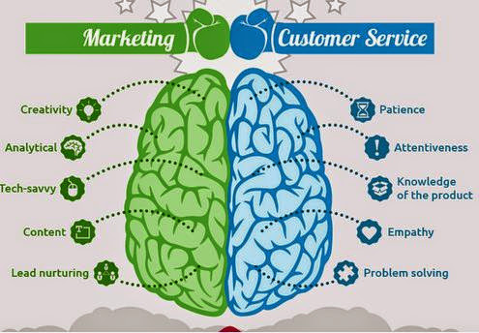 ***TOCE,(2017)***

***Figure 3:Marketing VS Customer Service***

Ethics refers to the scale of people between people, people and society, state, and behavior, also known as morality. As well as in some areas of marketing ethics also includes moral principles. In marketing, it aims to promote honesty, fairness and responsibility in all advertising. But the right or wrong lies in the subjective judgment of the individual. Ethics of marketing is a marketing strategy the helps companies guide their assessment. In the marketing staff must also comply with government and professional organizations to develop laws and standards. So that the privacy of consumers will be protected. Ethics of marketing has the distinction between advantages and disadvantages. Some companies use unethical advertising to gain a competitive advantage because unethical advertising is not necessarily illegal. However, those who want to improve the brand image, marketing ethics also established a trust between the company and the customer, the establishment of good relationship between the company and the customer, and the kind of unethical behavior of the company will soon collapse. Ethics of customer service personnel in a business, playing a very important role, related to the corporate image and reputation, because the customer service staff is directly face to face with the customer contact and communication. So in customer's impression, all their beliefs will on the attitude and behavior of customer service staff. As well as ethical customer service is representative of a company's professional brand symbol. However, each enterprise has its own moral values, the basic integrity is indispensable , which relates to the customer's trust in your company, ethical service or deceive customers, customer will gradually disappear, the company will face failure.

**Question 3**

Describe about Marketing strategies and how you can apply your studies in Hospitality Management.

Marketing strategy is the enterprise to customer needs as the starting point, according to experience to obtain customer demand and purchasing power of information, business expectations, planned organization of the business activities, through a coherent product strategy, price strategy, channel strategy and Promotion strategy, to provide customers with satisfactory products and services to achieve business goals in the process. Marketing strategies can be considered a business plan. Is the use of some professionals for the company to analyze or calculate the market research on the policy, economy, society, new technology or the needs of modern customers. The key information for marketing is the target customer information. In addition, the enterprise also implemented the strengths, weaknesses, opportunities and threats (SWOT) analysis is the internal and external conditions of the various aspects of the content of the integrated and summarized, and then analyze the strengths and weaknesses of the organization, opportunities and threats to a way.

1. **S**trengths- The use of the company's strengths, unique ability, skills to play specialty, to be successful, such as product quality, professional services.
2. **W**eaknesses- Weakness is relative to the competitors at a disadvantage in the internal capital defects, weaker than the other side. Such as lack of key skills and eligibility, obsolete equipment.
3. **O**pportunities- The potential opportunities for the company to develop and utilize the advantages of the environment, such as the expansion of new geographic areas, the expansion of product mix.
4. **T**hreats- The potential external threats to the company, to prevent and weaken the company's market position of environmental factors. Such as strong competitors to enter, population and environmental changes.

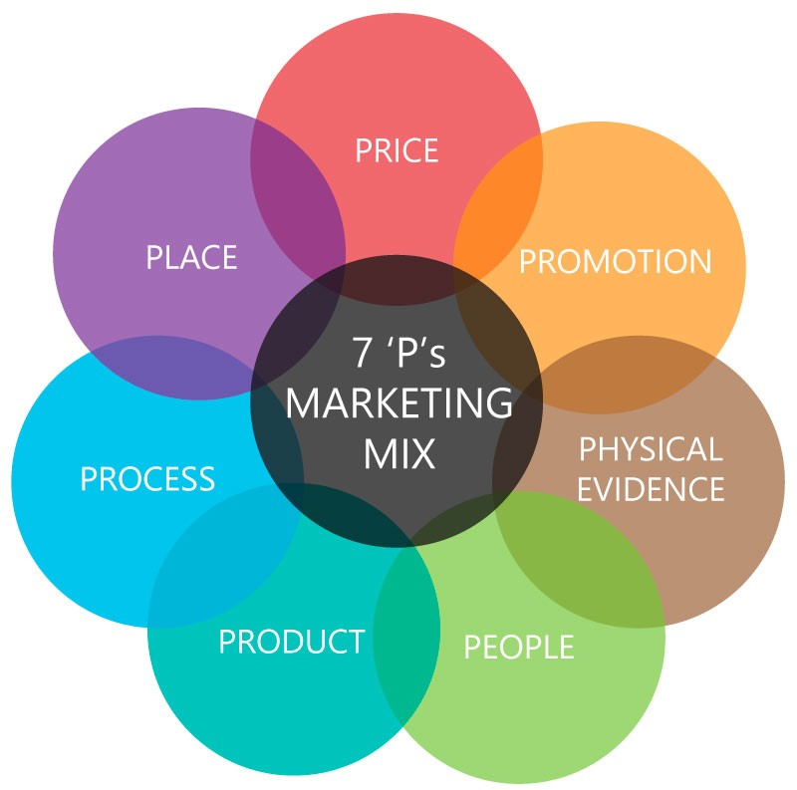

***Figure 4: 7P's The Marketing Mix***

One company is the first intuition to remember the brand. Brand is the product, service and logo established.

In the marketing, we can let customers understand us, we understand the customer, make the product or service more suitable for them, let them choose us. I took Starbucks Coffee as an example, founded in 1971; Starbucks has nearly 13,000 stores worldwide in North America, South America, Europe, the Middle East and the Pacific region. In an era where consumers are more informed and demanding, retaining customer loyalty takes more than creative advertising. So what is their marketing mix?



* **Price**

Price discount, customer cognitive value, quality and price ratio, differentiation

* **Place**

Accessibility, distribution channels, distribution scope

* **Product**

Product quality, level, brand, service items, guarantee, after-sales service

* **Promotion**

Advertising, staff marketing, publicity, public relations, image promotion, business promotion

* **Physical Evidence**

Tangible display environment design, equipment and facilities

* **People**

People attitude and behavior, reliability, responsibility, communication, customer participation

* **Process**

Employee decision - making, activity process, customer participation

Service marketing in the 7P's combination is a whole, seven elements of the combination, so that the overall effect to maximize the play. The enduring success of Starbucks Coffee and its sustainable business growth is illustrative of steadfastness in brand building, as well as effective product and brands management in a highly competitive marketplace.

**Question 4**

Explain in detail on Customer Service Skills and Characteristics.

Explain the Importance of Hospitality Customer Service.

In Hospitality customer service is one of the most important assets of any successful company. Quality customer service is customer-centric, satisfying customer's needs, improving customer satisfaction and creating superior value. Customer service personnel represent the company, because they are directly facing the customer, so the customer service staff need to have some customer service skills. Such as listening skills, to understand and understand the needs of customers, product knowledge, to answer questions asked by customers. However, the relationship with the customer does not actually bring any value, but also need to waste staff time and loss of a little financial resources. The following are some details about customer service.

|  |
| --- |
| **Customer Service** |
| Identification-Must clearly know our customers, the name and gender is to identify the guests first, must be called with the surname to show respect. |
| Solution Design- When we get customer parameters, in order to achieve the greatest degree to create and solve, and meet customer expectations. |
| Rapid Implementation- The rapid implementation of the customer's subtle needs to quickly resolve the customer's dissatisfaction. |
| Custom Development- In order to enhance business and customer relationships, custom development to help companies track sales and interaction between all customers. |
| Upgrades- The lack of services, to make up for timely, improve quality, not only can make up for the service problems, but also can make customer satisfaction. |
| User-Group Training- Employees have to learn new things, improve service attitude, increase knowledge and staff training. |
| Support- This is a sales service can't be ignored a content. There are plans to arrange the production of accessories, allowing users to timely procurement, to solve user difficulties. |

In every business, the most important thing in business is the customer, there is no customer no business. Customer is like God, and it is always right. Now in any business, customers are either before the purchase or after the purchase of the need to provide services to enhance customer satisfaction with us. The importance of hospitality customer service is to help create new customers to keep old customers, so that the whole company has a healthy business has been operating to develop new markets. Now in every business have to put more thought to pick and train customer service employees. The impact of customer service employees in fact the entire marketing activities have a certain significance. Enterprise employees are the main body of business organizations, each employee to do everything, have a certain impact on the image of the enterprise. Should allow each employee to take the initiative to participate in the enterprise management decision-making. In addition, we should also pay attention to the whole process of providing services to users, through interactive communication to understand the customer in the process of feeling, so that customers become a participant in the service marketing process, so as to timely improve their services to meet customer's expect. Enterprise marketing should also pay attention to the internal division of labor and cooperation between the various departments of the management process, because marketing is a collaboration by the various departments, all employees to participate in activities, and effective division of labor between departments is the fundamental guarantee to achieve marketing activities.

 ***JUMIA TRAVEL,(2016)***

***Figure 5: The importance of Customer Service***

**Conclusion**

In this assignment of Marketing and Customer Relationship, I learned a lot about the small details and the importance of marketing and customer relationship in the business. On the first question, it describes all about the importance of marketing in hospitality to the business. For instance, how to understand the needs of customers from marketing, establish and maintain the relationship between the two sides, through these values to create work, with the marketing spread, your sales will be steady growth to be successful. In the second question, we can understand and see the differences between Marketing and Customer Service like a different skill and operation and also the ethics of marketing and customer service in hospitality. As in marketing ethics aimed at promoting honesty, fairness and responsibility for all advertising. In this persuasive, the moral customer service represents the company's professional brand symbol, which relates to the customer's trust in the company is absolutely can't be ignored. From the third question, it describes what is the concept of marketing strategies. Marketing strategies can think of business plans, using some of the company's expertise (SWOT) Strengths and Weaknesses, Opportunities and Threats to analyze, and use 7P's Price, Place, Product, Promotion, Physical Evidence, People, Process to obtain success. In conclusion of the third question, they are essential to the success of the service industry. Whether the service business is a place of entertainment, or a consulting firm or a restaurant, all affect all the details. Simultaneously, in last question, I understand of customer service skills and the importance of hospitality customer service any success of the company the most important. The most important thing is the customer, but the customer service staff is the biggest source of the impact of the guests. As well as Good customer service can enhance the company's energy, but also to maintain a strong tool for customers, so that customers like to close to the company. In the enterprise, Marketing and Customer Relationship if can be with the perfect, then the company will create outstanding achievements and value.

**References**

1. ***MARKETING IN ASIA*** , (2009) CASE WAS WRITTEN BY ROGER A.KERIN , STEVEN W.HARTLEY, WILLIAM RUDELIUS, LAU GEAK THENG FOR THE MCGRAW-HILL COMPANIES.
2. TOCE,(2017) ***THE OVERALL CUSTOMER EXPERIENCE***,RETRIVED FROM <https://plus.google.com/102884595583695323054>
3. ALWYN COSGROVE,(2016) ***HIERARCHY OF FITNESS MARKETING***, RETRIVED FROM <http://athletesacceleration.com/hierarchy-fitness-marketing/>
4. ANCHOR MARKETING,(2017) ***PLANNING FOR MARKETING AND MARKETING FROM A PLAN***,RETRIVED FROM <https://www.anchorwebsite.com/planning-for-marketing-and-marketing-from-a-plan/>
5. DAVE SCHNEIDER,(2017)***CRM MODELS (CUSTOMER RELATIONSHIP MANAGEMENT MODEL)***,RETRIVED FROM <https://ninjaoutreach.com/crm-models/>
6. WIKIPEDIA,(2017) ***MARKETING STRATEGY***,RETRIVED FROM <https://en.wikipedia.org/wiki/Marketing_strategy>
7. STARBUCKS.(2017) ***ABOUT STARBUCKS***, RETRIVED FROM <https://www.starbucks.com/coffee>
8. PROFESSIONAL ACADEMY , ***MARKETING THEORIES – THE MARKETING MIX – FROM 4 P’S TO 7 P’S***, RETRIVED FROM<https://www.professionalacademy.com/blogs-and-advice/marketing-theories---the-marketing-mix---from-4-p-s-to-7-p-s>
9. KRISTIE LORETTE,(2017) ***CUSTOMER SERVICE CHARACTERISTICS***, RETRIVED FROM <http://smallbusiness.chron.com/customer-service-characteristics-756.html>
10. OSCAR KIMANUKA,(2014)***WHY CUSTOMER SERVICE IN HOSPITALITY INDUSTRY IS EVERYTHING***,RETRIVED FROM <http://www.newtimes.co.rw/section/read/183956/>
11. ESER HANGUL,(2017) ***6+ EFFECTIVE MARKETING PROCESS***,RETRIVED FROM <https://tinobusiness.com/6-effective-marketing-process/>
12. JUMIA TRAVEL,(2016) ***THE IMPORTANCE OF CUSTOMER SERVICE***, RETRIVED FROM <https://travel.jumia.com/blog/the-importance-of-customer-service-insights-by-omolara-3822>

**Appendix**

Example:

